SODA Partnership Management Group
Terms of Reference
March 2024

Purpose
The PMG is an integral part of the governance structure of the SODA, supporting the development and delivery of the SODA work programme.

Figure 1. SODA Governance Structure
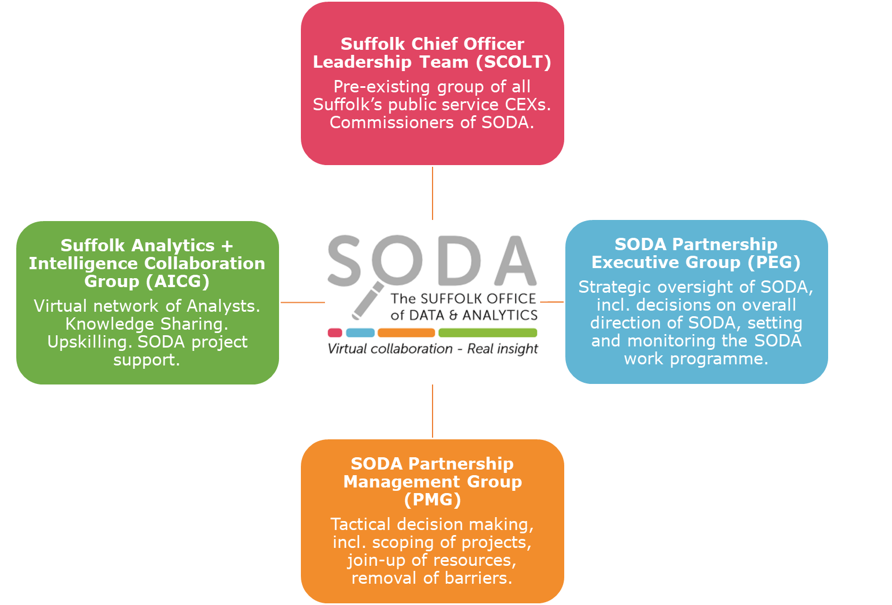

Key tasks/objectives
Developing and supporting the SODA work programme
- Horizon-scanning for potential new areas of work.
- Support the scoping of SODA projects and sign of project ToRs before submission to PEG.
- Ensuring that each organisation supports and works within the Suffolk Data Sharing Framework.
- IT strand support.
System connectors
- Facilitating joined up working between the SODA partners.
- Identifying ways to overcome barriers to collaborative working.
- Connecting SODA to service-specific staff responsible for datasets within each organisation.
- Connecting SODA to relevant IG and IT staff within each organisation.

SODA resourcing
- Facilitate the join-up of resources to respond to commissioned work by the SODA PEG.
- Ensuring a fair distribution of analytical resource between all SODA partners.
- Deal with any capacity issues of staff supporting SODA WORK, e.g., where analysts working on SODA projects raise any difficulties with time or resource.
- Support the mapping of analytical and research assets (both people and data) and technical capabilities amongst SODA partners.
- Work with SODA on skills audits, training, and development programmes to ensure we build an effective network of analysts.
- Make recommendations to the SODA PEG about the need for more or different resources.

Membership
Organisation / Team
Babergh & Mid-Suffolk Councils
East Suffolk Council
Ipswich Borough Council
Suffolk Office of Data & Analytics
Suffolk & North-East Essex Integrated Care Board
Suffolk Constabularies
Suffolk County Council:
- Adult and Children & Young People Services Data Hub Team
- Corporates Services – IT/Data Engineering Team
- Public Health & Communities Intelligence Team
Suffolk Fire and Rescue Service
West Suffolk Council

Ways of Working
- The SODA PMG is a virtual group that communicates and makes decisions via email. Partners can request virtual / hybrid meetings for specific project requests or to discuss key tasks / objectives.
- Where decisions need to be made, information will be circulated to all members and a reasonable time given for consultation and response.
- The decision-making process will be mutual consent, with final responsibility resting with the PEG.

