SODA Partnership Executive Group
Terms of Reference
April 2024
Purpose
The PEG is an integral part of the governance structure of the SODA, setting and monitoring the SODA work programme.
Figure 1. SODA Governance Structure
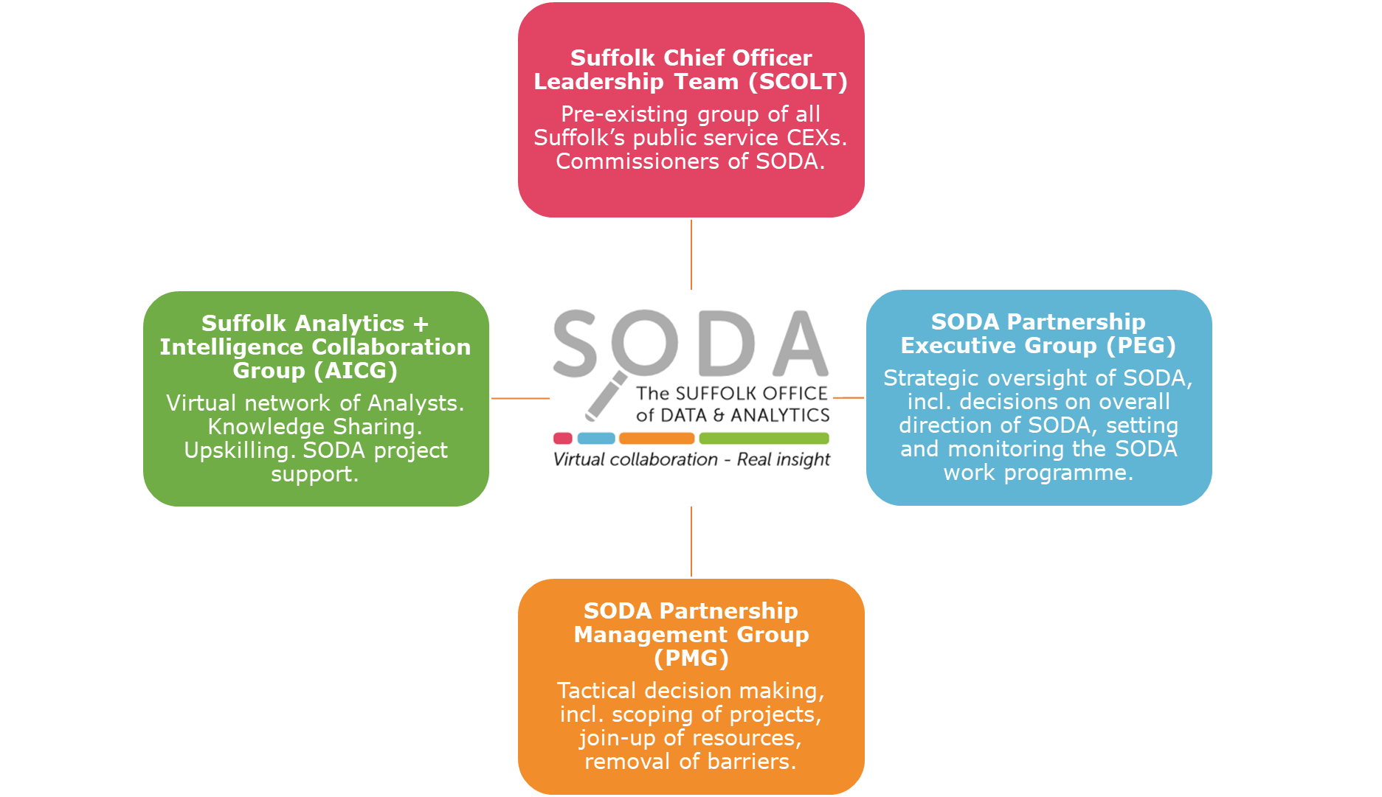

Key tasks/objectives
Setting and monitoring the SODA work programme and budget
- Prioritising, agreeing and commissioning projects.
- Ensuring that each organisation supports and works within the Suffolk Data Sharing Framework.
System connectors
- Overseeing and facilitating joined up working between the SODA partners.
- Removing barriers to collaborative working, where these have been identified by the PMG.
SODA resourcing
- Overseeing the staffing arrangements of dedicated SODA staff, based on the recommendations of their hosting organisation; the Head of Knowledge and Intelligence, Suffolk County Council and the SODA Manager (Analytical Lead).
- Committing staff resource from within their organisation to projects on the SODA work programme.
- Ensuring a fair distribution of analytical resource between all SODA partners.
- Ensuring that, where the need for an additional piece of analytical work arises that is over and above the capacity of SODA or the network of virtual analysts, additional resource can be contributed by one of the Parties, or an external partner, to allow this work to be completed.

Membership
Organisation
Babergh District & Mid Suffolk District councils
East Suffolk Council
Ipswich Borough Council
Suffolk & North-East Essex Integrated Care Board
Suffolk Office of Data & Analytics
Suffolk Constabulary
Suffolk County Council
West Suffolk Council

Ways of Working
- The Suffolk Chief Officer Leadership Team (SCOLT) Lead for the SODA PEG is Chris Bally, Chief Executive, East Suffolk Council.
- The SODA PEG is a virtual group that is called upon on an adhoc basis when new project requests are submitted to SODA, when barriers to collaborative working need to be removed, or when decisions on SODA resourcing need to be made. The SODA Manager will contact the SODA PEG via email, giving reasonable time for consultation and response. Once responses have been collated, the SODA Manager will inform the SODA PEG of the final decision. The decision-making process will be by consensus and agreement of those responding. Where consensus and agreement cannot be reached, the issue will be deferred to SCOLT in the first instance and SPSL in the second.
- PEG members can raise any issues or queries with either the SODA Lead or SODA PEG Chair directly.
- SODA will report to SCOLT twice per annum on work programme and progress and also prepare an Annual Report for Suffolk Public Sector Leaders (SPSL).
- A review of these Terms of Reference will be carried out at every 5 years or as otherwise requested by SCOLT, in line with the SODA Partnership Management Agreement.

